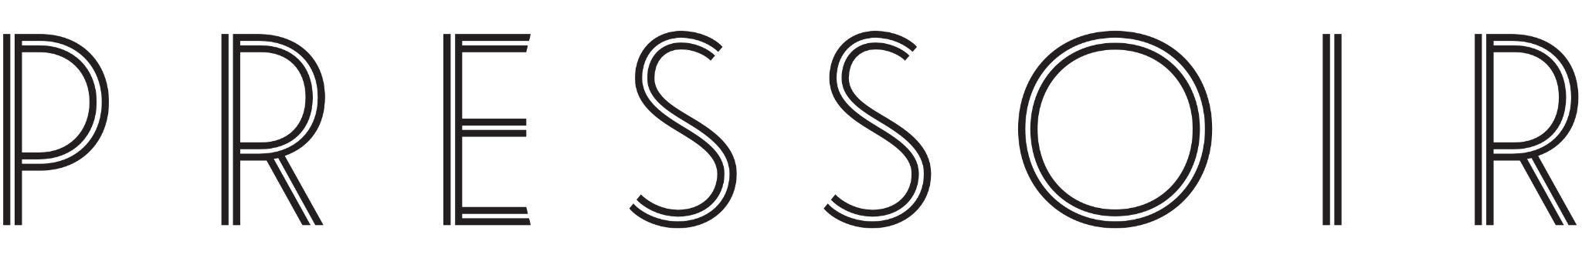

MEDIA CONTACT
Alyssa Young, MMGY Wagstaff
pressoir@wagstaffmktg.com
516.398.9274

LA PAULÉE FESTIVAL BRINGS BURGUNDY
TO LOS ANGELES
Indulge in the Wines of Burgundy Alongside Acclaimed Producers & Celebrated Chefs at Luxury Tastings, Seminars & Dinners in the Greater Los Angeles Region
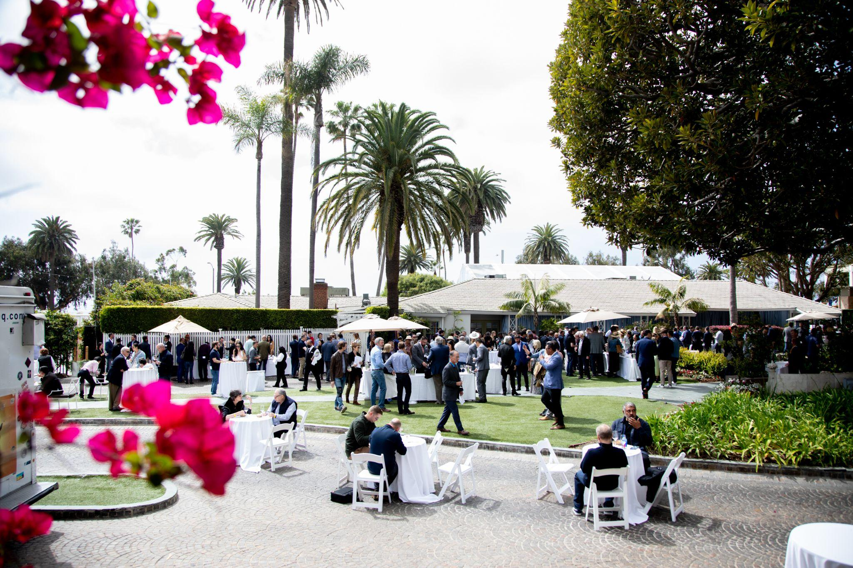
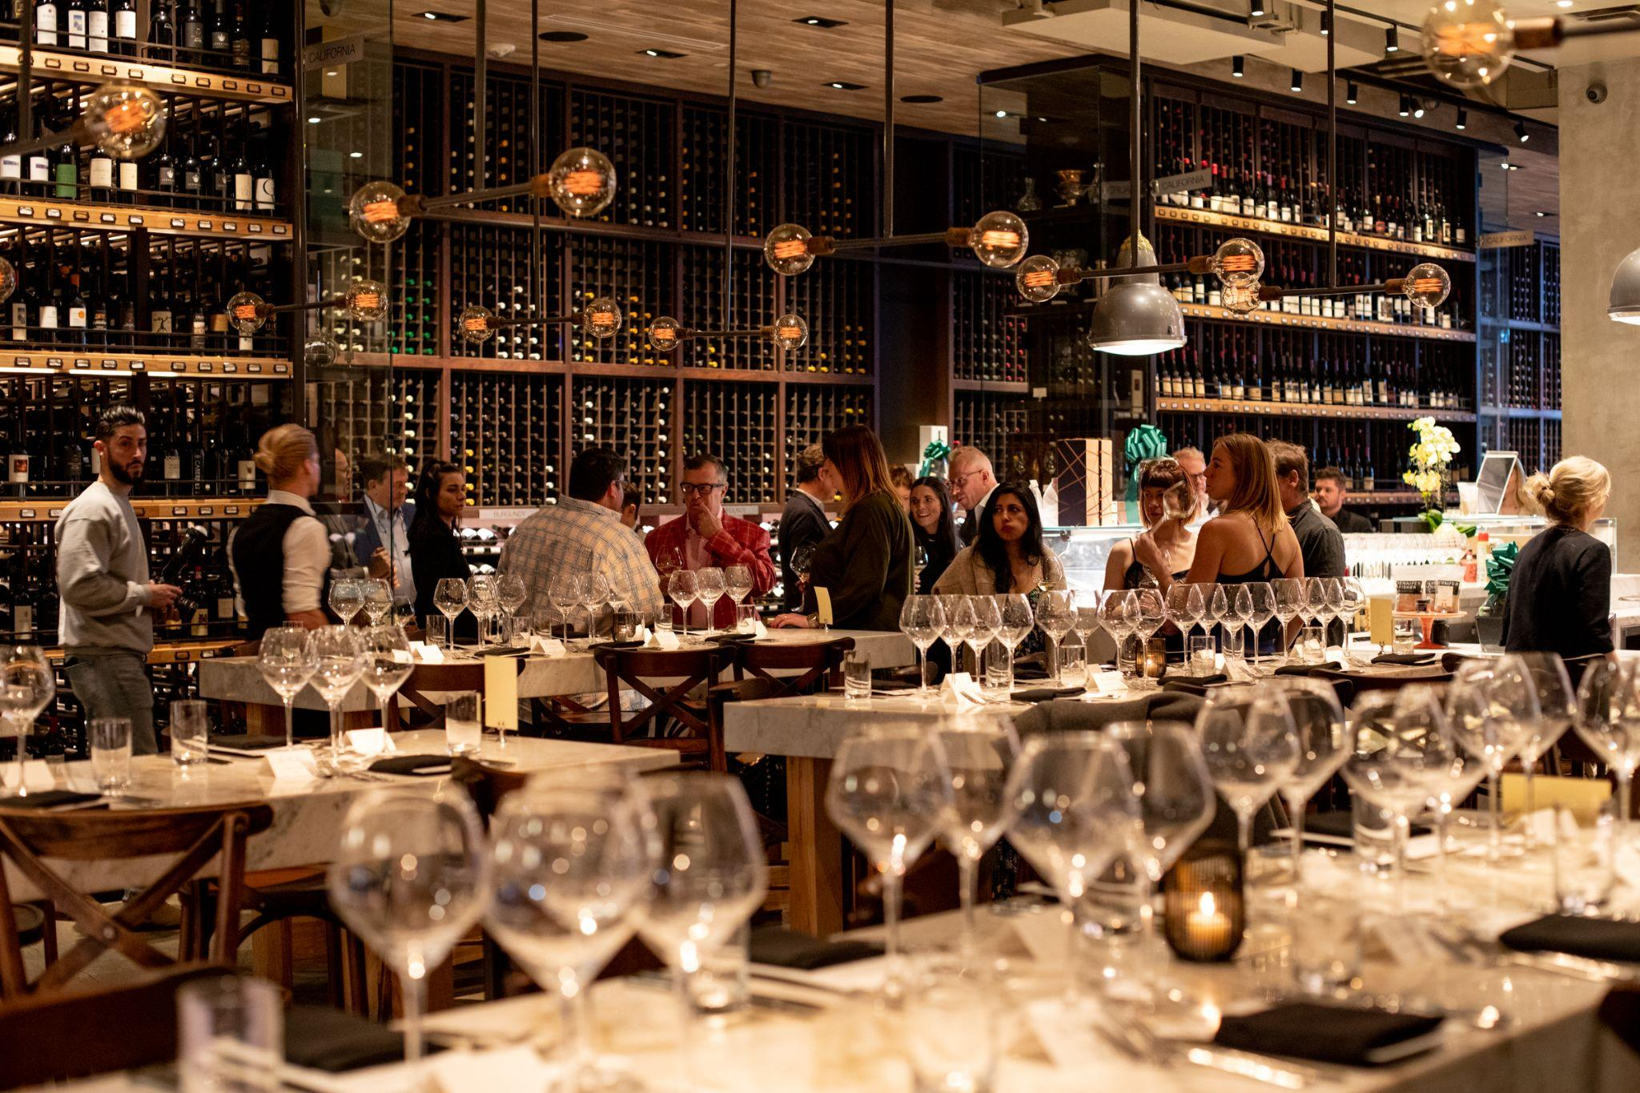

LOS ANGELES, JANUARY 16, 2024 – La Paulée, the internationally acclaimed celebration of Burgundy’s wine and culture, is set to debut its highly anticipated 2024 Festival in Los Angeles this February 27-March 2. The festival pays homage to the acclaimed region’s rich heritage, showcasing the finest wines, cuisine, and celebrated producers, one-of-a-kind tastings, seminars, lavish dinners, and collaborations with Los Angeles’ top chefs. La Paulée is produced by world-renowned sommelier Daniel Johnnes and his organization Pressoir, the team behind top French wine festivals La Fête du Champagne and La Tablée.

After years of cultivating significant relationships with winegrowers in the region, the Pressoir team has personally invited Burgundy’s finest producers to present their wines at this year’s La Paulée in Los Angeles. Wine lovers of all types – from serious collectors to curious novices – can indulge their passion for the intensely fragrant and fruity flavors that are embodied by Burgundian wines.

The La Paulée festival is inspired by Burgundy’s own celebration, La Paulée de Meursault which began in 1923 and is held at the end of each grape harvest: an extravagant luncheon that starts at noon on Monday at the Château de Meursault and continues well into the evening. The U.S. iteration first launched in New York in March 2000 in an effort to transport the region’s spirit of generosity and camaraderie to American wine lovers, and since then, the annual festival has also taken place in San Francisco and Aspen, CO. This is the second year it will be produced in Los Angeles.

Tickets will be available for purchase to the general public beginning on Wednesday, January 31 at 10am ET, through the official La Paulée website. In addition, American Express Centurion Card® Members can take advantage of early ticket access beginning Tuesday, January 16 at 12pm ET, while American Express Platinum Card® Members can purchase beginning Wednesday, January 17 at 12pm ET. Both grant access to special ticket packages and exclusive experiences.

The full program of events, details, and pourings can be found at the La Paulée website. For more information and updates, follow La Paulée on Instagram.
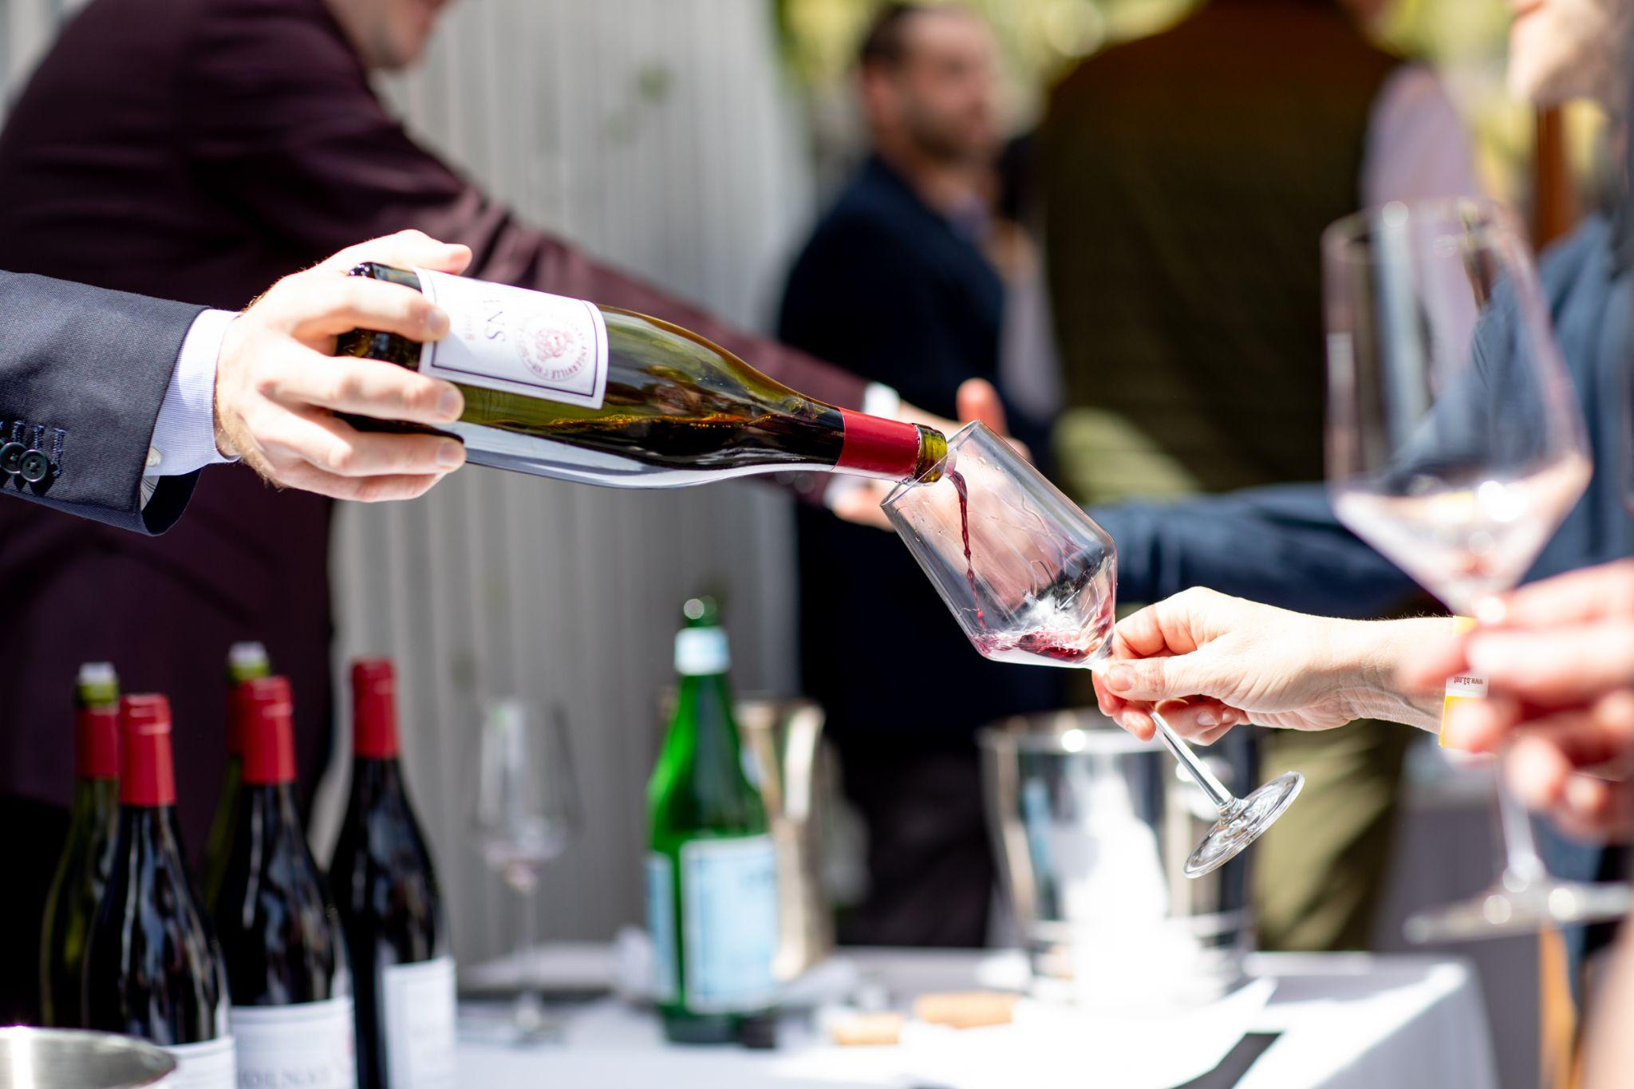

LA PAULÉE 2024 PROGRAM
Tuesday, February 27
- Domaine de Montille Dinner: with Etienne de Montille
La Paulée will kick off in Los Angeles with a very special evening with Etienne de Montille and a brilliant selection of wines direct from Domaine de Montille's cellars in Volnay. Following a vertical of Puligny-Montrachet 1er Cru Le Cailleret, guests will explore the breadth of de Montille’s remarkable Côte de Beaune holdings through the superb 2012 and 2010 vintages. Guests will then taste an exceptional trio of Malconsorts from the 2005 vintage, including the “regular” Malconsorts cuvée, the limited “Christiane” cuvée (made from a unique parcel just next to the original part of La Tâche and bordered by the same roads), and the “Enfant” cuvée, which Etienne only made in 2005 as a trial blend of all of Malconsorts and never commercially released. The dinner will conclude with a stunning vertical of de Montille’s signature Volnay Taillepieds back to the heralded 1985 vintage. The wines will be paired with a tasting menu from Chefs Wolfgang Puck & Ari Rosenson at Chef Puck’s legendary Beverly Hills restaurant Spago.
  - Location: Spago |176 N Canon Dr, Beverly Hills, CA
  - Time: 6:30pm | Racines Wine Reception
  - Cost: $1,650

Wednesday, February 28
- La Paulée Off Grid: A Tasting of Burgundy’s Hidden Gems
La Paulée’s popular “Off Grid” tasting is proof positive that the joys of Burgundy can be accessible. The best way to discover all that Burgundy has to offer, this tasting will feature a selection of over 75 wines from all the major regions of Burgundy, including Chablis, Côte d'Or, Côte Chalonnaise, Mâcon, and Beaujolais, as well as a number of Aligotés, curated by top sommelier Taylor Grant. Enjoy cuisine from Redbird and a selection of fine purveyors. Connect with the sommeliers on hand who will share their picks from Burgundy and provide tips on great value wines, up-and-coming winemakers, and surprising vintages.
Please note that this is an outdoor event.
- Location: Redbird Garden | 114 E 2nd Street, Los Angeles, CA
- Time: 5:30pm-8:00pm
- Cost: $150

- Dinner with Domaine Antoine Jobard & Domaine Hudelot-Noëllat: with Antoine Jobard & Charles Van Canneyt
Join Antoine Jobard & Charles Van Canneyt, two of Burgundy’s most highly respected vignerons, for an exclusive dinner showcasing their amazing terroirs in the Côte de Beaune & Côte de Nuits. Direct from their domaines’ cellars in Burgundy, the lineup of wines will begin with twin verticals of Antoine’s top cuvées, Meursault Charmes & Genevrières. We will then head north to the Côte de Nuits to explore Charles’ interpretations of Malconsorts and Romanée-Saint-Vivant. The wines will be paired with a tasting menu at Chef Jon Yao’s restaurant Kato, one of Los Angeles’ hottest tables and the LA Times’ number one restaurant.
- Location: Kato | 777 S Alameda St Building 1, Suite 114, Los Angeles, CA
- Time: 7:00pm | Champagne Delamotte Reception
- Cost: $1,200

Exclusively for American Express Centurion® and American Express Platinum® Card Members. Enter the 10-digit toll-free Customer Service phone number (without spaces, dashes, or the initial “1”) from the back of your Card as a promo code on Eventbrite to unlock access to tickets for this event.

Thursday, February 29
- Dinner with Domaine Pierre Morey & Domaine Fourrier: with Anne Morey & Jean-Marie Fourrier
Two estates that are emblematic of their villages, Meursault & Gevrey-Chambertin, respectively, Domaine Pierre Morey and Domaine Fourrier produce some of the finest wines in all of Burgundy from top vineyard sites. Anne Morey & Jean-Marie Fourrier have provided a stellar selection of wines from their cellars for this exclusive dinner, from Morey’s Perrières & Bâtard-Montrachet, to Fourrier’s Clos Saint Jacques & Griotte-Chambertin. The wines will be paired with the fine cuisine of Chef Walter Manzke at his elevated French restaurant Bicyclette.
- Location: Bicyclette | 9575 W Pico Blvd, Los Angeles, CA
- Time: 6:30pm | Champagne Delamotte Reception
- Cost: $1,200

Friday, March 1
- Verticals Tasting
This is a unique opportunity to taste three-vintage verticals of a signature wine from participating domaines in an intimate walk-around tasting in The Maybourne’s Garden Terrace in the heart of Beverly Hills. Please note that this is an outdoor event. Heaters will be provided if necessary.
- Location: The Maybourne Garden Terrace | 225 N Canon Dr, Beverly Hills, CA
- Time: 5:00pm-7:30pm
- Cost: $595

- Domaine Ponsot Dinner: with Rose-Marie Ponsot & Alexandre Abel
The family’s Domaine Ponsot meticulous farming and cellar work create some of the most sought-after wines in Burgundy. La Paulée is honored to have estate director Rose-Marie Ponsot, of the family’s fourth generation, along with head winemaker Alexandre Abel, with us to present a fantastic lineup of wines that showcase Domaine Ponsot’s renowned quality, many of which will be poured from rare magnums. The dinner will begin with Ponsot’s celebrated Clos des Monts Luisants, the only Premier Cru in Burgundy allowed to be made from Aligoté. Following a flight of the Cuvée des Alouettes, Ponsot’s red from Monts Luisants, dinner will close with flights of two of the domaine’s incredible Grands Crus - Chapelle-Chambertin and the celebrated Clos de la Roche. The wines will be paired with an Italian-inspired menu from Chef Sal Marino, whose cuisine has been favored for decades by Los Angeles’ wine community at Il Grano and his family’s namesake restaurant Marino.
- Location: Marino Restaurant | 6001 Melrose Ave, Los Angeles, CA
- Time: 7:00pm | Champagne Delamotte Reception
- Cost: $1,200

Saturday, March 2
- Terroirs of Chablis Masterclass with Didier Séguier of Domaine William Fèvre
Join Didier Séguier, winemaker at Domaine William Fèvre, for a lively and engaging seminar exploring the diversity of the terroirs of Chablis, through a fantastic selection of five wines showcasing Fèvre’s considerable holdings, including three of the Grands Crus.
- Location: Fairmont Miramar | 101 Wilshire Blvd, Santa Monica, CA
- Time: 11:00am-12:00pm
- Cost: $195

- Grand Tasting
This is a walk-around tasting in the Fairmont Miramar’s beautiful Moreton Bay Circle, offering guests the opportunity to taste the highly acclaimed and ultra-limited 2021 vintage, as well as back vintages, and mingle with attending winemakers from participating Burgundy domaines, while enjoying food prepared by some of Los Angeles’ most noteworthy restaurants and fine purveyors, including Andante Dairy, Camphor, Cassia, Farmshop, Fig, Haute Caviar, Juliet, La Colombe, Marino, Maude, Navarro’s, and Taylor Shellfish. Over one hundred wines will be presented. Please note that this is an outdoor event. Heaters will be provided if necessary.
- Location: Fairmont Miramar | 101 Wilshire Blvd, Santa Monica, CA
- Time: 12:00pm-3:00pm
- Cost: $495

- Gala Dinner: with Chefs Daniel Boulud, Michael Cimarusti, Josiah Citrin, Walter Manzke, and Dave Beran
La Paulée’s namesake Gala Dinner will feature a menu prepared by acclaimed Chefs Daniel Boulud of DANIEL, Walter Manzke of République, Bicyclette, and Manzke restaurant, Michael Cimarusti of Providence, Josiah Citrin of Citrin & Mélisse, and Dave Beran of Pasjoli. In the tradition of La Paulée de Meursault, guests are invited to bring treasures from their cellars to share alongside those from attending winemakers, adding to the convivial and generous atmosphere in the room.
- Location: Fairmont Miramar | 101 Wilshire Blvd, Santa Monica, CA
- Time: 6:30pm | Champagne Delamotte Reception
- Cost: $1,600

La Paulée is proud to host the greatest estates of Burgundy
Château de Béru • Bouchard Père & Fils • Maison Chanterêves • Domaine Yvon Clerget
Domaine Clos de la Chapelle • Clos de Tart • Domaine des Croix • Maison Joseph Drouhin Domaine d’Eugénie • Domaine William Fèvre • Domaine Didier Fornerol
Domaine Jean-Marie Fourrier • Domaine Génot-Boulanger • Domaine Henri Gouges
Les Hospices de Beaune • Domaine Hudelot-Noëllat • Maison Louis Jadot
Domaine Antoine Jobard • Domaine des Comtes Lafon • Domaine Hubert Lamy
Domaine Leflaive • Domaine Antoine Lienhardt • Domaine de Montille • Domaine Pierre Morey • Domaine Georges Noëllat • Domaine Ponsot • Domaine Nicolas Rossignol • Domaine Rougeot • Domaine Camille Thiriet • Domaine de la Vougeraie
and featuring Les Aligoteurs, Champagne Salon & Champagne Delamotte.

###

ABOUT PRESSOIR
Founded by celebrated wine expert Daniel Johnnes, whose influence on the wine and hospitality industry is recognized far and wide, Pressoir is the country’s leading wine organization honoring the Burgundy, Champagne, and Rhône Valley regions. Pressoir originated with the first La Paulée event held in the U.S. in 2000, designed to bring the wine and culture of Burgundy to American wine lovers. Since then, the Pressoir team has built an organization that is dedicated to showcasing French wine and culture through a range of events and services.

